1. [Java Regex | HackerRank](https://www.hackerrank.com/challenges/java-regex/problem?isFullScreen=true)

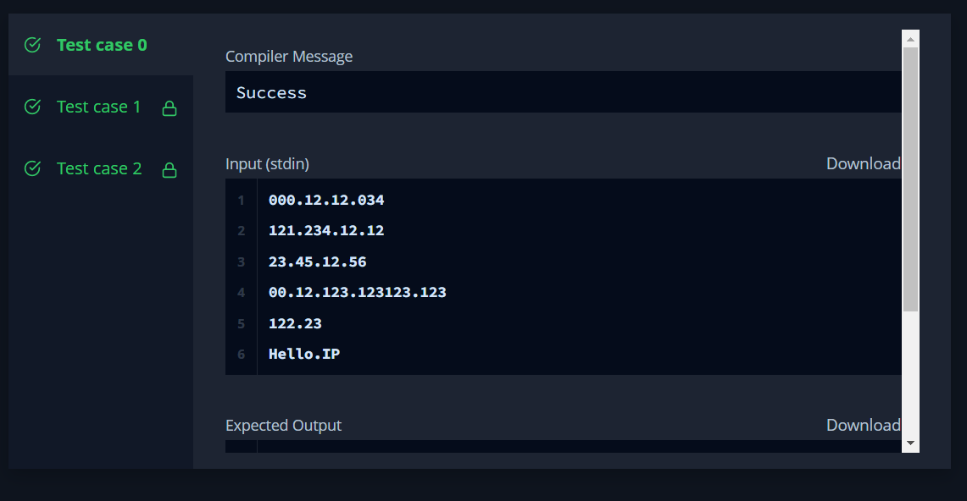

1. <https://www.hackerrank.com/challenges/duplicate-word/problem?isFullScreen=true>

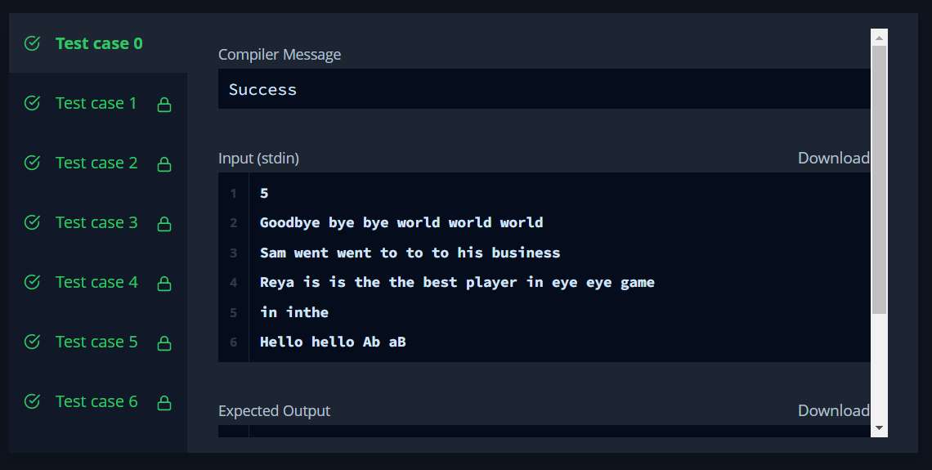

1. [Tag Content Extractor | HackerRank](https://www.hackerrank.com/challenges/tag-content-extractor/problem?isFullScreen=true)

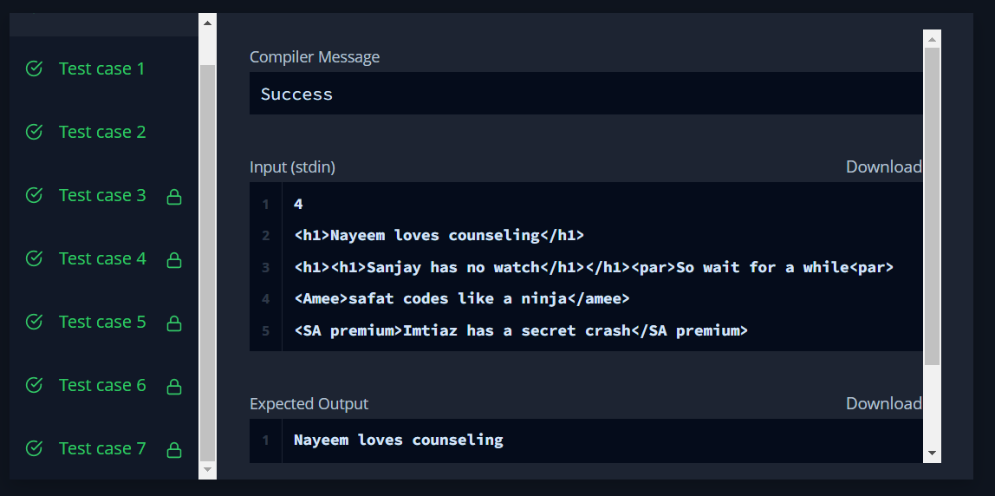

1. [Java BigDecimal | HackerRank](https://www.hackerrank.com/challenges/java-bigdecimal/problem?isFullScreen=true)

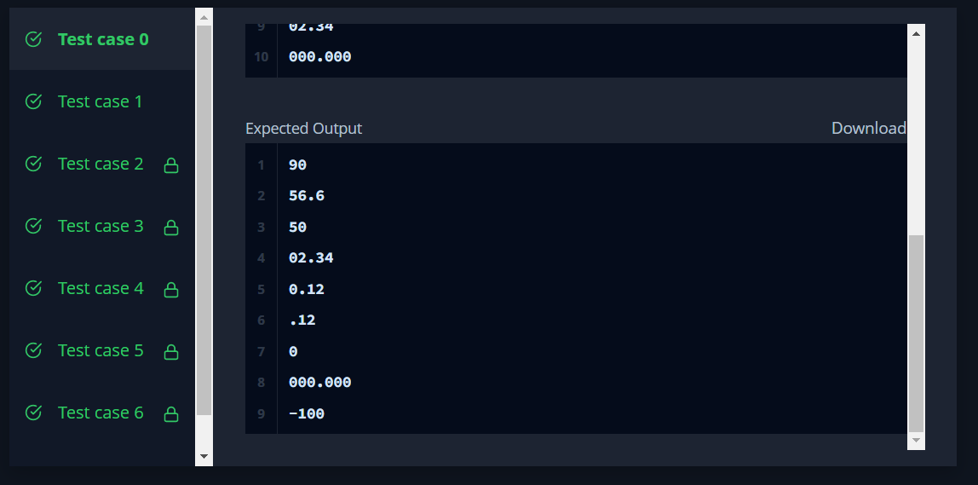

1. [Java 1D Array (Part 2) | HackerRank](https://www.hackerrank.com/challenges/java-1d-array/problem?isFullScreen=true)

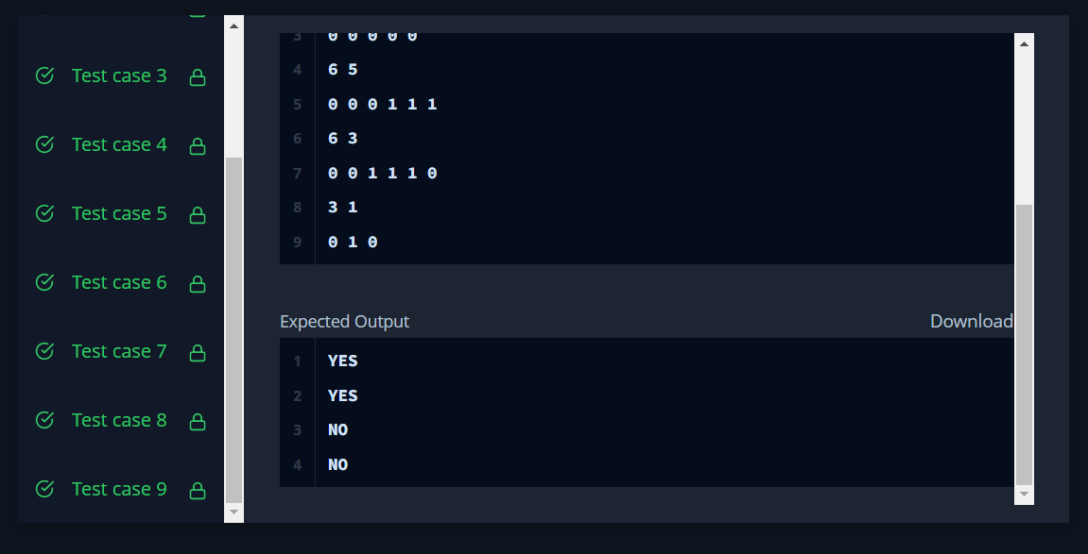

1. [Java Stack | HackerRank](https://www.hackerrank.com/challenges/java-stack/problem?isFullScreen=true)

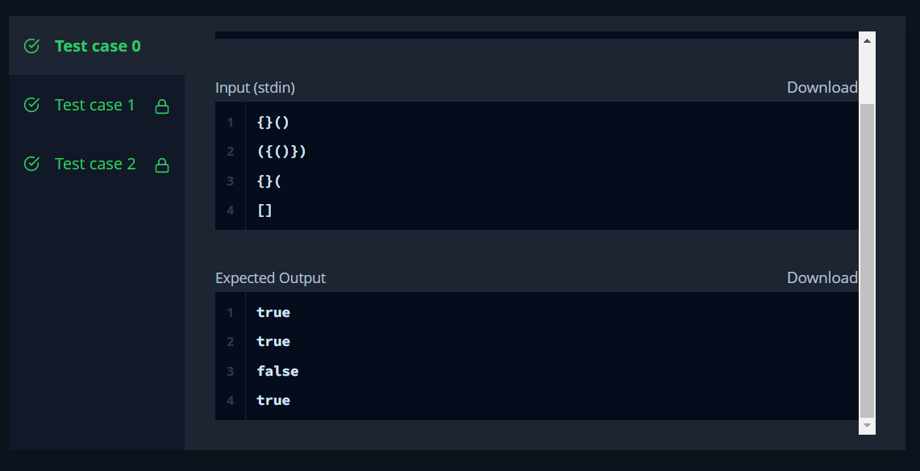

1. [Java Comparator | HackerRank](https://www.hackerrank.com/challenges/java-comparator/problem?isFullScreen=true)

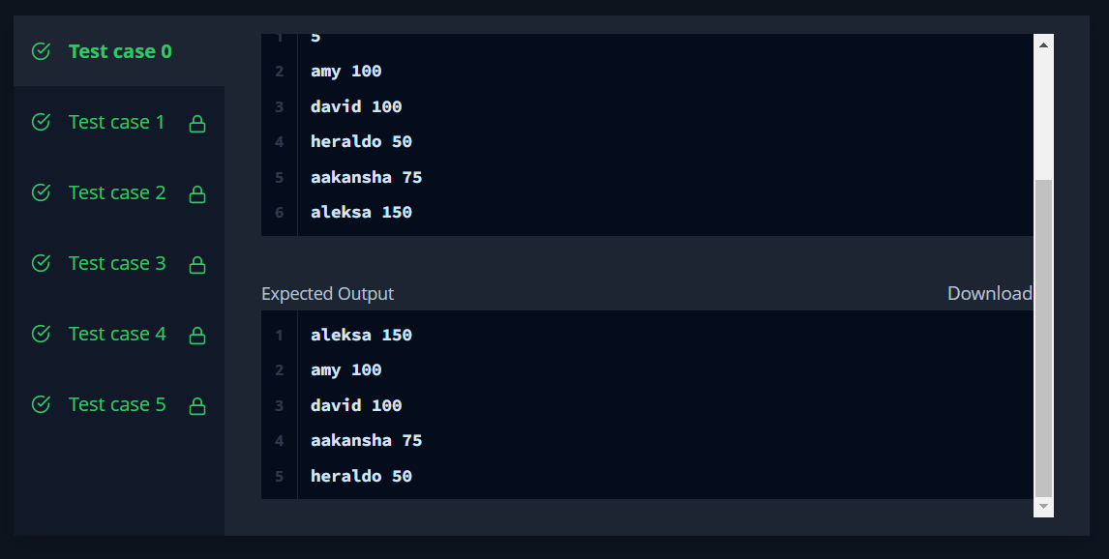

1. [Java Dequeue | HackerRank](https://www.hackerrank.com/challenges/java-dequeue/problem?isFullScreen=true)

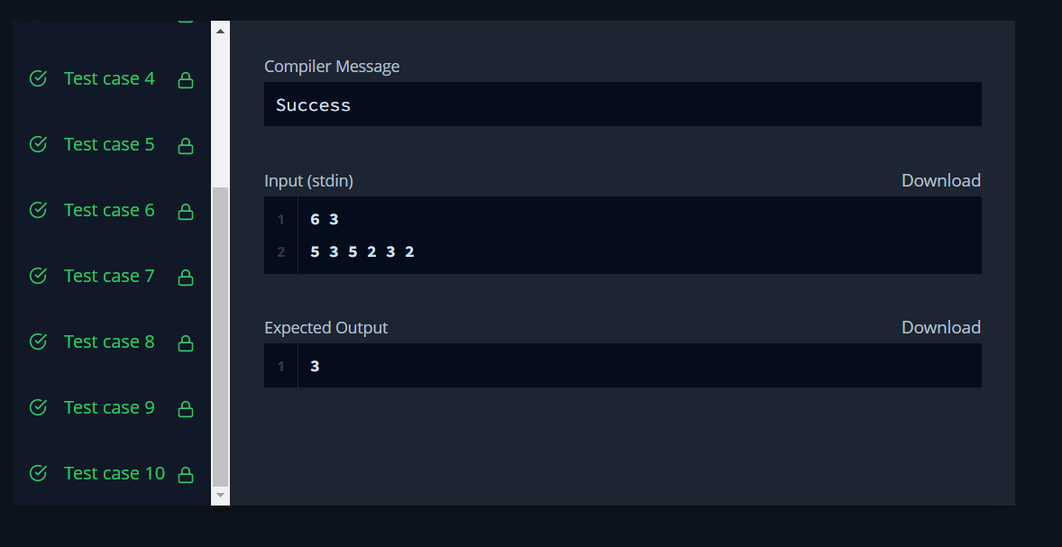

1. [Java Priority Queue | HackerRank](https://www.hackerrank.com/challenges/java-priority-queue/problem?isFullScreen=true)

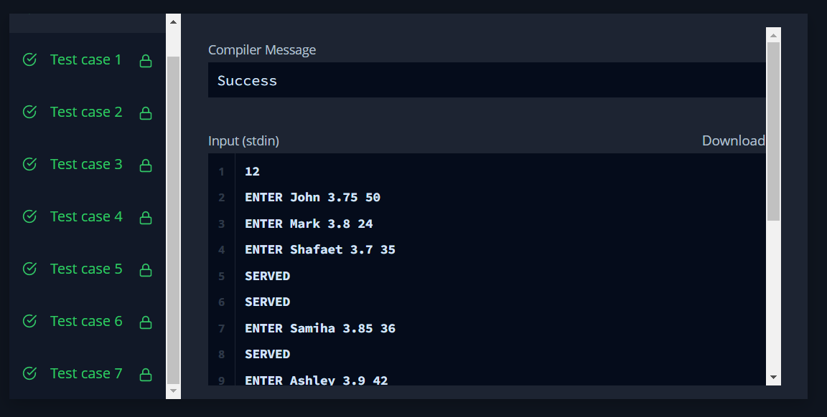

1. [Can You Access? | HackerRank](https://www.hackerrank.com/challenges/can-you-access/problem?isFullScreen=true)

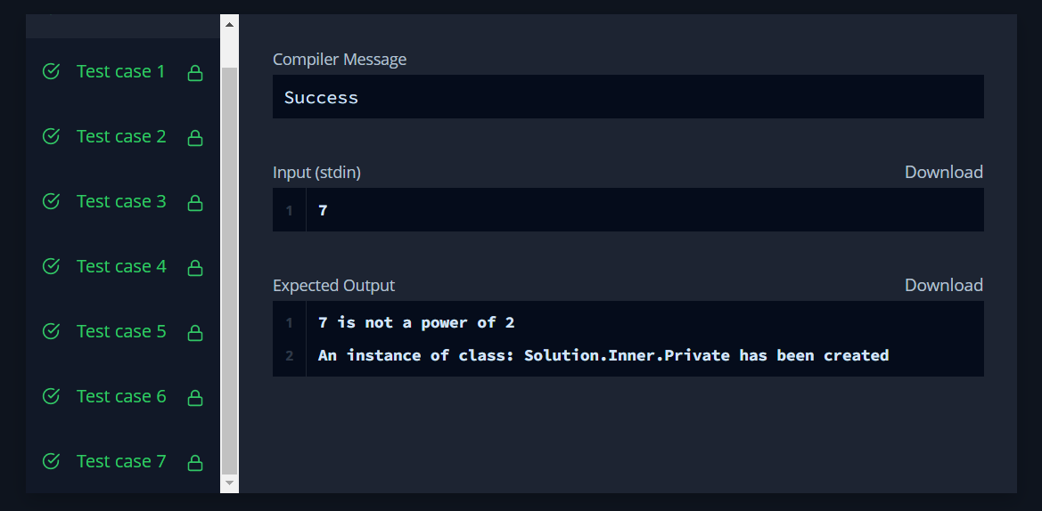

1. [Prime Checker | HackerRank](https://www.hackerrank.com/challenges/prime-checker/problem?isFullScreen=true)

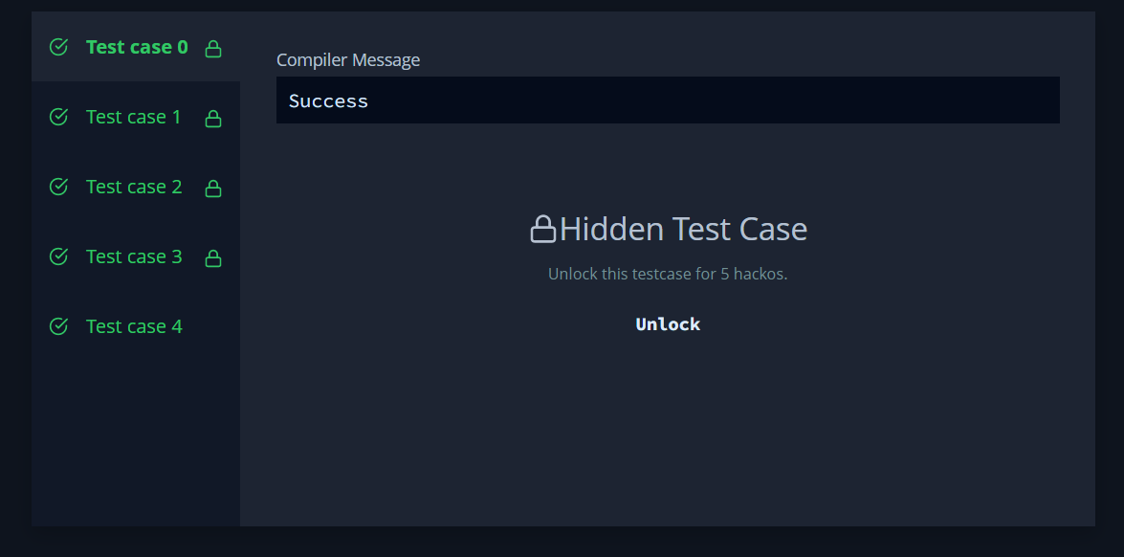

1. [Java Annotations | HackerRank](https://www.hackerrank.com/challenges/java-annotations/problem?isFullScreen=true)

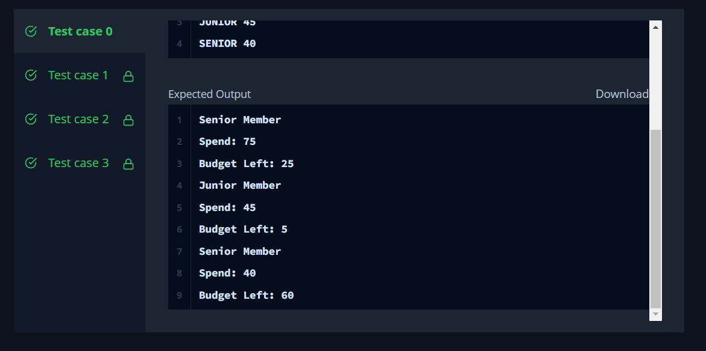

1. [Java Lambda Expressions | HackerRank](https://www.hackerrank.com/challenges/java-lambda-expressions/problem?isFullScreen=true)

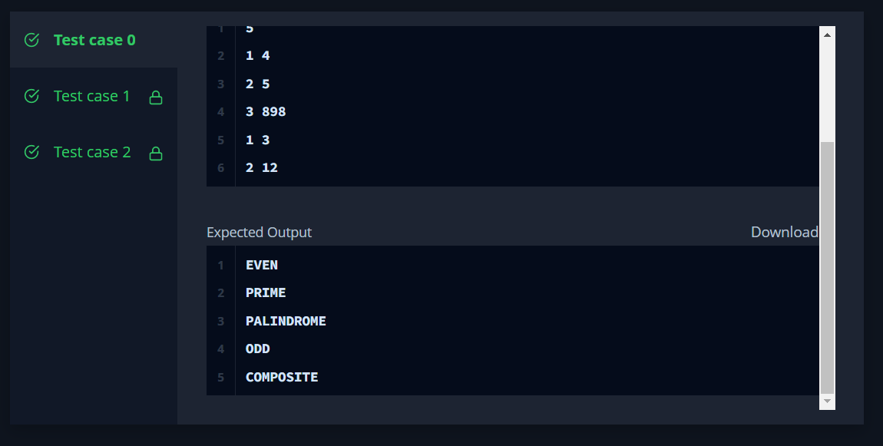

1. [Java MD5 | HackerRank](https://www.hackerrank.com/challenges/java-md5/problem?isFullScreen=true)

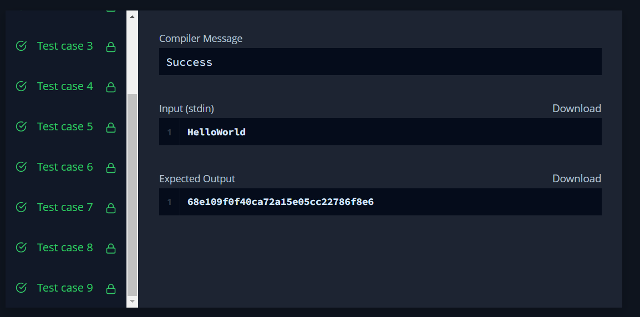

1. [Java SHA-256 | HackerRank](https://www.hackerrank.com/challenges/sha-256/problem?isFullScreen=true)

